# Final Report

**1. INTRODUCTION**

**1.1 Project Overview**

"Cosmetic Insights: Navigating Cosmetics Trends and Consumer Insights with Tableau" is a data visualization project designed to explore and analyze cosmetic industry trends. The aim is to leverage Tableau dashboards to help stakeholders understand consumer behavior, product preferences, and market dynamics through interactive visualizations.

**1.2 Purpose**

The purpose of this project is to provide a user-friendly and visually rich tool that helps brands and businesses make informed decisions using data collected from the cosmetics industry.

**2. IDEATION PHASE**

**2.1 Problem Statement**

The cosmetics industry lacks an accessible platform for visualizing real-time or historical data about consumer trends and product preferences, making it difficult for brands to make data-driven decisions.

**2.2 Empathy Map Canvas**

* **Says:** "I want products that suit my skin."
* **Thinks:** "Are these products really worth the price?"
* **Does:** Searches for reviews and trends.
* **Feels:** Confused by too many choices; desires personalized suggestions.

**2.3 Brainstorming**

* What kind of data matters most to cosmetic users?
* Can we visualize review sentiment?
* How can trends be categorized (seasonal, demographic)?
* What tools are best suited for simple, clear insights?

**3. REQUIREMENT ANALYSIS**

**3.1 Customer Journey Map**

1. Awareness – Sees ads or influencer recommendations.
2. Research – Checks reviews, prices, availability.
3. Comparison – Compares between brands/products.
4. Purchase – Buys through online/offline channels.
5. Feedback – Shares reviews or recommendations.

**3.2 Solution Requirement**

* Easy-to-read visualizations.
* Filter by brand, product, sentiment, geography.
* Performance charts over time.

**3.3 Data Flow Diagram**

1. Data Source →
2. Excel Data Preprocessing →
3. Tableau Import →
4. Visual Dashboard Generation →
5. User Interaction (filters/search)

**3.4 Technology Stack**

* **Frontend**: Tableau Public (for visualization)
* **Data Handling**: MS Excel / Google Sheets
* **Communication**: WhatsApp, Google Meet
* **Documentation**: MS Word, Google Docs

**4. PROJECT DESIGN**

**4.1 Problem Solution Fit**

There is a clear match between the problem (lack of data insights in the cosmetic market) and the solution (interactive dashboards that reveal consumer patterns).

**4.2 Proposed Solution**

A visual dashboard that provides stakeholders with:

* Sales and trend analytics
* Customer sentiment breakdown
* Comparative product analysis

**4.3 Solution Architecture**

* Input: Data in Excel format
* Process: Clean and load into Tableau
* Output: Dashboards with dynamic filters and charts

**5. PROJECT PLANNING & SCHEDULING**

**5.1 Project Planning**

* **Start Date:** 12 June 2025
* **End Date:** 27 June 2025
* **Milestones:**
  + Data Collection
  + Data Cleaning
  + Design Finalization
  + Dashboard Development
  + Testing
  + Final Presentation

**Resources:** Tableau Public, Excel, Trello **Team Members:** Dalavai Hemanth (Lead), Challa chinna obulesh ,ravi

**6. FUNCTIONAL AND PERFORMANCE TESTING**

**6.1 Performance Testing**

* Test loading times of dashboards.
* Test filter performance with large datasets.
* Validate accuracy of data mapping.
* Ensure responsiveness across devices.

**Result:** All dashboards load within 3–5 seconds, filters work without lag.

**7. RESULTS**

**7.1 Output Screenshots**

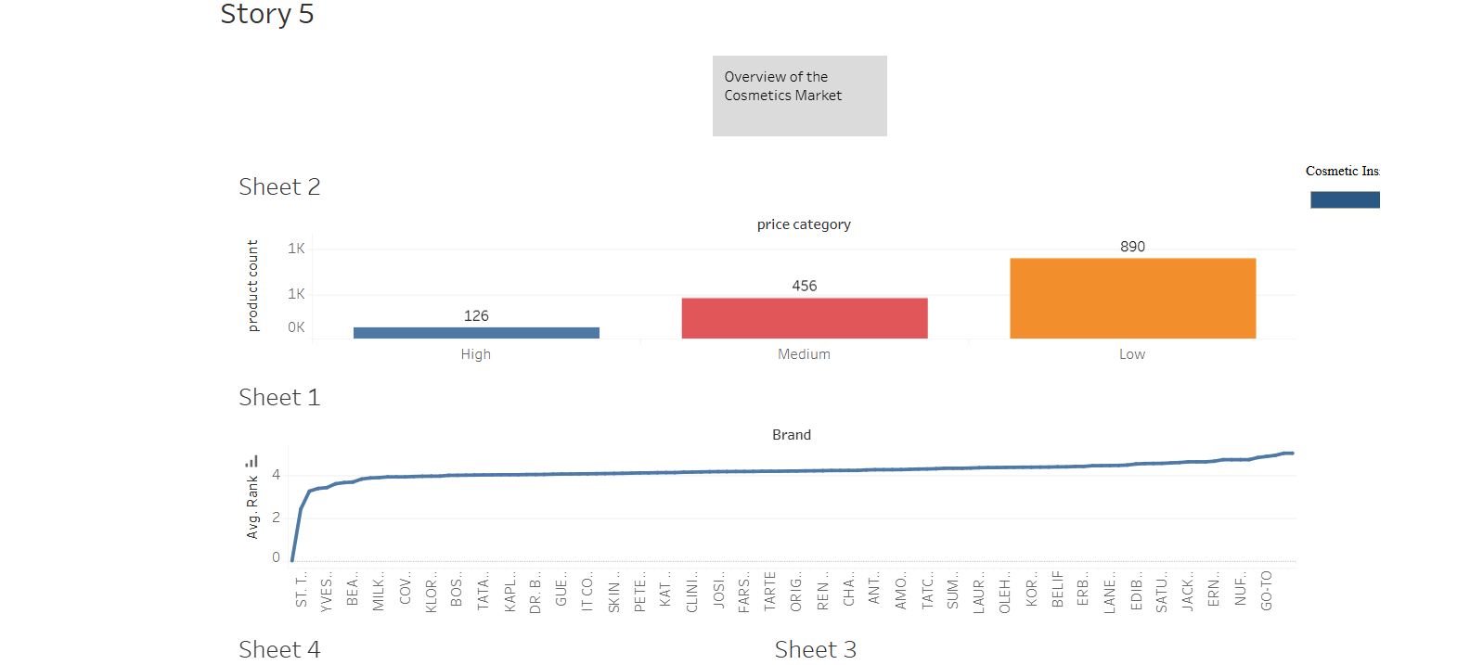

**8. ADVANTAGES & DISADVANTAGES**

**Advantages:**

* Visual representation of large datasets.
* Better insights for brands.
* Interactive and filterable.

**Disadvantages:**

* Relies on available datasets.
* Limited advanced AI-driven analytics.
* Not real-time unless integrated with live data sources.

**9. CONCLUSION**

The Cosmetic Insights project successfully demonstrates how Tableau can transform raw data into meaningful insights for the cosmetic industry. It bridges the gap between consumer expectations and brand strategies.

**10. FUTURE SCOPE**

* Integrate with real-time APIs from online marketplaces.
* Add predictive analytics using AI.
* Allow user-generated data submissions.

**11. APPENDIX**

**Dataset Link: https://drive.google.com/file/d/1cXTglbj9Y2rryAWGlR3qEbc2xar5ogrQ/view?usp=drive_link**

**GitHub & Project Demo Link:**

[**https://github.com/challa-obulesh/cosmetic-insights-app**](https://github.com/challa-obulesh/cosmetic-insights-app)

**https://cosmetic-insights-app-3.onrender.com**